Quantitative Risk Assessment Using the Indicators & Warning (I&W) Technique
Pfizer Inc. / Seagen Acquisition | Group 10 | Module 3
Following the Module 3 approach, we started with qualitative analysis to work through and rank all sixteen risks in our register, then brought in quantitative methods only where the stakes were high enough to justify the added depth. For risks that landed lower in priority, qualitative monitoring is sufficient there’s no value in running a full model on something that doesn’t warrant it. We ran a complete quantitative pass on the three priority competitive risks: ADC market-share erosion (threat), critical ADC talent poaching (threat, R-006), and the first-mover ADC combination-therapy opportunity (R-010). This summary explains the methods chosen, the steps taken, and the high-level results now reflected in the Risk Register.

Why the Indicators & Warning (I&W) technique

Competitive risk in the ADC space does not sit still it shifts constantly across the 18–24 month integration window, which makes a one-time score largely useless on its own. The I&W technique was the right fit here because it takes each qualitative risk and turns it into a set of measurable, forward-looking indicators with clear warning thresholds attached (amber and red triggers). That gives us three things a static rating simply cannot: probability estimates grounded in observable signals rather than gut feel; escalation triggers that are auditable and repeatable; and indicators that do double duty feeding the model and serving as the live KRIs that management actually monitors day to day. As a concrete example, market-share erosion is tracked through competitor ADC approvals and Phase 3 starts measured against Seagen’s share trend, with a trigger set at a >5% annual share decline or three or more competitor approvals in a year.

Why Monte Carlo simulation, with a machine-learning extension

The consequence of each risk is a range, not a single point our DCF stress testing shows a 10% revenue miss erodes deal value by roughly $4.42B, and a 20% miss takes it to about $9.57B. A single expected-value calculation throws away all of that uncertainty, which is exactly the information decision-makers need. Monte Carlo simulation was the right choice because it takes the full probability and impact ranges and propagates them into an outcome distribution, giving us P50, P90, and a scenario value-at-risk that can actually support threshold-based decisions. We modelled probability and impact as triangular distributions minimum, most-likely, maximum and ran 100,000 iterations per risk. Looking ahead, the probability inputs could be sharpened further using a supervised machine-learning classifier, such as logistic regression or gradient boosting, trained on historical biopharma M&A integration outcomes with the same I&W indicators as features. Monte Carlo would then propagate the impact uncertainty around whatever the model learns. We treat the ML layer as a forward-looking enhancement rather than a current output, since a properly labelled training set was outside the scope of this assignment.

Steps taken to quantify probability and impact

- Picked the three priority competitive risks out of the qualitative Module 2 assessment chosen for their competitive relevance and the fact they came out with the highest risk scores.
- Built out the I&W indicators for each risk leading, coincident, and lagging signals pulled from publicly available sources (ClinicalTrials.gov, Drugs@FDA, SEC EDGAR) alongside internal attrition data.
- Set amber and red warning thresholds for each indicator so that raw signals translate into clearly defined escalation states rather than being left open to interpretation.
- Used the current indicator readings to convert each risk into a triangular probability range minimum, most-likely, and maximum rather than forcing a single point estimate.
- Tied each impact range directly to the team’s DCF model and register figures a 10% revenue miss works out to roughly $4.42B in deal value erosion, a 20% miss to about $9.57B and expressed those ranges as triangular distributions.
- Ran 100,000 Monte Carlo iterations, drawing probability and impact each time to produce expected loss or value, P50, P90, and a Bernoulli-based scenario value-at-risk for each risk.
- Moved the high-level outputs into the Risk Register under the new Quant I&W Assessment tab, and documented the full model in the appended notebook and data file.

High-level results

ADC market-share erosion is the standout exposure an expected loss of $2.66B and a P90 scenario value-at-risk of $6.67B. Talent poaching is a smaller expected loss at $0.37B, but a 55% probability is high enough that it cannot sit on the back burner; active retention controls are warranted now. On the upside, the first-mover combination opportunity partially offsets both threats, contributing roughly $0.83B in expected upside value.
Risk | Type | Mean Prob. | Impact P50 ($B) | Impact P90 ($B) | Exp. Loss/Value ($B) | Scenario VaR P90 ($B)
ADC market-share erosion | Threat | 53.3% | 4.86 | 7.48 | −2.66 | 6.67
Critical ADC talent poaching (R-006) | Threat | 55.0% | 0.65 | 0.95 | −0.37 | 0.87
First-mover ADC combinations (R-010) | Opportunity | 50.0% | 1.64 | 2.11 | +0.83 | +1.95
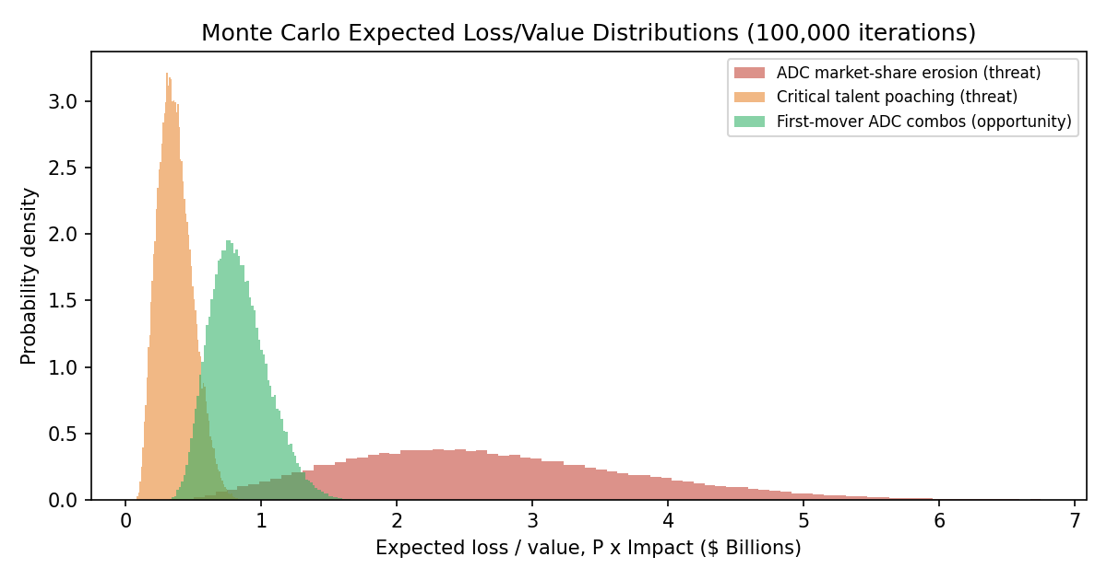
Figure 1. Monte Carlo expected loss/value distributions (100,000 iterations; full code in appended notebook).

References

Committee of Sponsoring Organizations of the Treadway Commission. (2017). Enterprise risk management: Integrating with strategy and performance. AICPA.
Fleisher, C. S., & Bensoussan, B. E. (2015). Business and competitive analysis: Effective application of new and classic methods (2nd ed.). Pearson FT Press.
Grabo, C. M. (2004). Anticipating surprise: Analysis for strategic warning. University Press of America.
Hubbard, D. W. (2020). How to measure anything: Finding the value of intangibles in business (3rd ed.). Wiley.
Munos, B. (2009). Lessons from 60 years of pharmaceutical innovation. Nature Reviews Drug Discovery, 8(12), 959–968.
Pfizer Inc. (2023). Pfizer completes acquisition of Seagen [Press release].
Vose, D. (2008). Risk analysis: A quantitative guide (3rd ed.). Wiley.

